AE Log Viewer User’s Guide
Application Enablement
November 08, 2014
Contents
Log Viewer User’s Guide 3
Intended Audience 3
What is Log Viewer 3
Security 3
Log Viewer Screen Overview 3
Logon Prompt 3
Log Viewer Screen 3
Log Viewer Detail Screen Overview 8

AE Log Viewer User’s Guide

Intended Audience
This document is intended for anyone who is interested to view the logs using AE Log Viewer application.

What is AE Log Viewer
AE Log Viewer is a common medium to view the log messages for multiple applications (UPM, Foundation and WMB) in various environments. It provides the capability to search the logs with many different parameters.

Security
AE Log Viewer provides a user authentication and authorization using Active Directory Global groups. Non AE users should request group membership to get access to view the log messages.

AE Log Viewer Screen Overview

Logon Prompt
At the logon prompt enter your MS domain Window user id and password. Press Login to authenticate your user name/password credentials and authorize your use of the system.

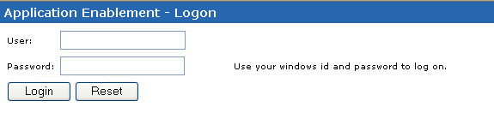

AE Log Viewer Screen
After successfully logging into the system you will be presented with the Log Viewer screen.

The screen is divided by Search Criteria and Search Results.

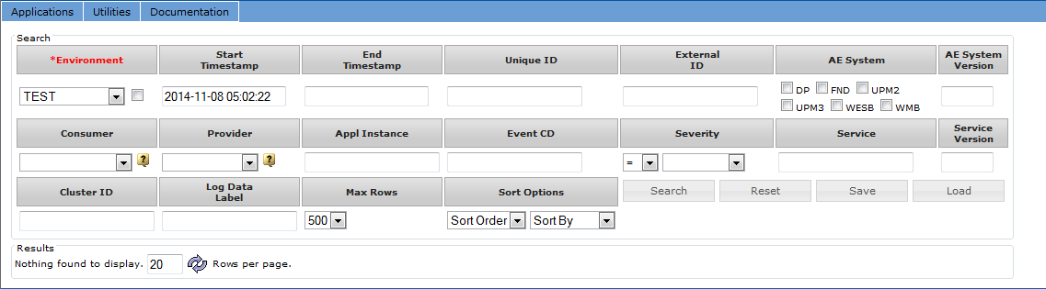

Search Criteria allows you to search the logs by entering some filter conditions.
By default the start time stamp is set to one hour before the current time, the sort order is set to ascending and the max rows is set to 500.

Environment provides a capability to search on a particular environment. It would be the application environment for UPM (dev, devint, uata etc.), CICS regions for Foundation (UHGTG4T1, UHGTUPT1 etc.) and Queue managers for WMB (WMBT01, WMBRM02 etc.). It is internally mapped to the corresponding environments based on the selection criteria. This field is mandatory for any search without the unique id. With the unique id, this field is ignored.

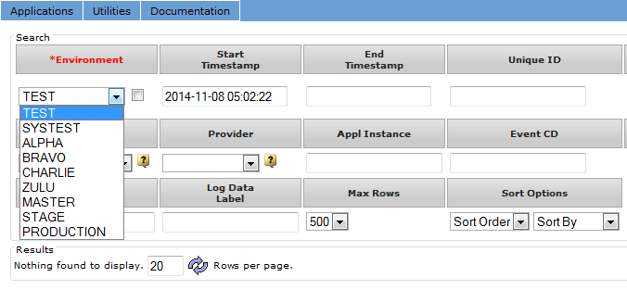

Start Time Stamp is set to one hour before the current time by default. This field is mandatory for any search without the unique id. With the unique id, this field is ignored.

Unique ID is the system generated unique id of the service call. This field is mandatory if the Start Time Stamp is not present.

The Severity field has options to search with a particular severity or more than a particular severity. If “>=” is selected, the log messages with more than or equal to that severity are displayed.

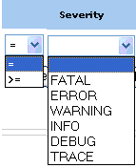

The maximum number of results fetched from the search is defaulted to 500. This can be changed using the Max Rows drop down.

The log messages are sorted in ascending order of the time stamp by default. To view the recent messages, the sort order can be changed to descending.

Search function
The search can be further narrowed by using any of the other fields. Once the search criterion is ready, Search button can be clicked to view the search results. The search results are sorted either in the ascending or descending order of the time stamp based on the selected sort order.

The search function groups the results by the unique id and the first message in the group is displayed in the results section.

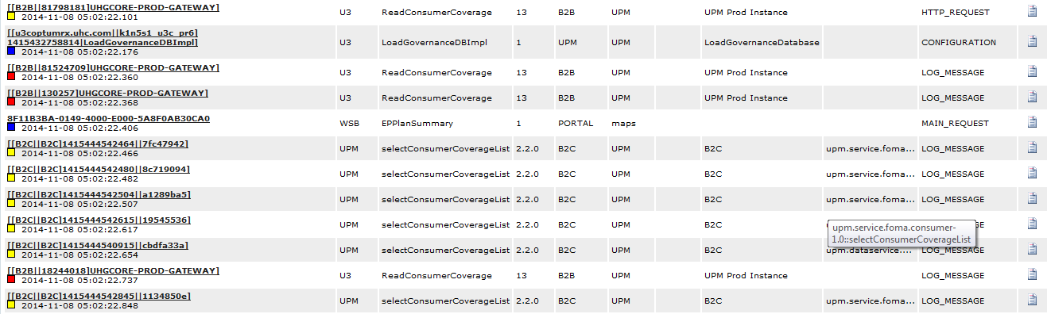
Unique ID hyper link
Log Details link
Log Details link

Unique ID hyperlink
Each unique id is displayed with a hyper link. The complete set of results for a particular unique id can be viewed by clicking on the hyper link.

Back to Search Results link
When the log messages are viewed by the unique id, another link called “Back to Search Results” is displayed above the search results. This link navigates back to the original search result set and avoids clicking the back button on the browser. This link is available only when the unique id hyper link is clicked.

Severity
The severity level is displayed with a unique colored block beside the time stamp for each log message in the search results section. The color represents a severity level.
Severity
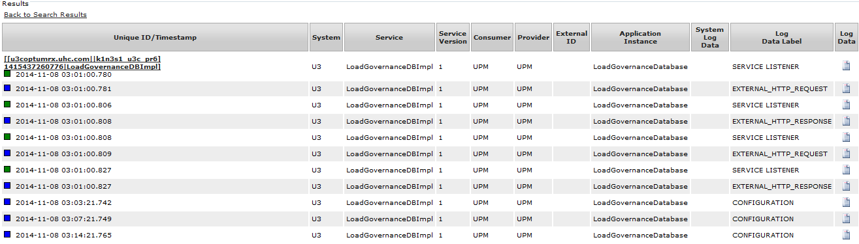
Back to Search results

Search by unique Id for non AE users

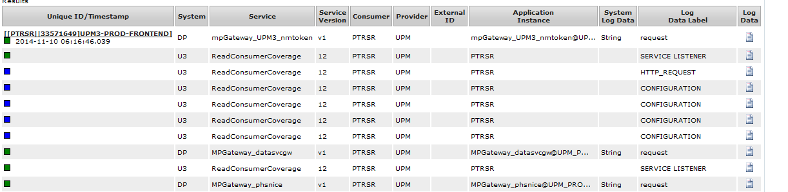

Non AE users do not have the privilege to view the complete details with the unique id search. They can only see the first line in the series.

Refresh & Page navigation
By default, a maximum of 20 rows are displayed per page in the results section. This can be changed by entering a desired number and clicking the “refresh” button. If the results span across multiple pages, the next or previous set can be viewed by clicking either the or buttons.

Save function
Each search is saved and is displayed as a hyper link with the time stamp in the search criteria section. When the hyper link is clicked, the screen is loaded with the search criteria and the corresponding results. At any time a maximum of 5 recent searches can be seen.

The saved searches are only available for that particular user session. Search criteria can also be persisted permanently by clicking the “Save” button. “Save” function saves the last performed search to the database for the current user.

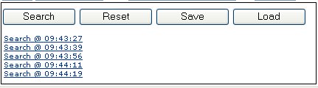

Load function
The saved searches can be viewed by clicking the “Load” button. When the load button is clicked, the screen is refreshed with all the saved searches for the current user. Each search is displayed with a hyper link with the time stamp the search is performed. Another link “delete” is displayed next to each search link to delete the search permanently. The “Cancel” button navigates back to the Log Viewer search screen in the previous state. When the hyper link on any search criteria is clicked, the Log Viewer screen is displayed with the search criteria from the saved search and the results corresponding to it.

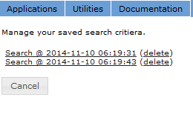
Saved searches hyper link

Delete Saved search

Reset function
“Reset” button clears all the values in the search and results sections and loads the screen with the defaults.

AE Log Viewer Detail Screen Overview
The detailed view of a log message can be seen by clicking on the button in the search results section. The details are opened in a new window as below.
The details of the log message are shown in a tabular format and the actual content of the message is shown in the bottom half of the window.

The content of the message is showed in different formats based on the data type of the message. The Base64 messages are decoded, the XML messages are formatted to a readable format and the Foundation messages are formatted to a wrapped text. The message can also be viewed in its original format by clicking on the “Raw Data” tab. The view can be switched between the tabs.

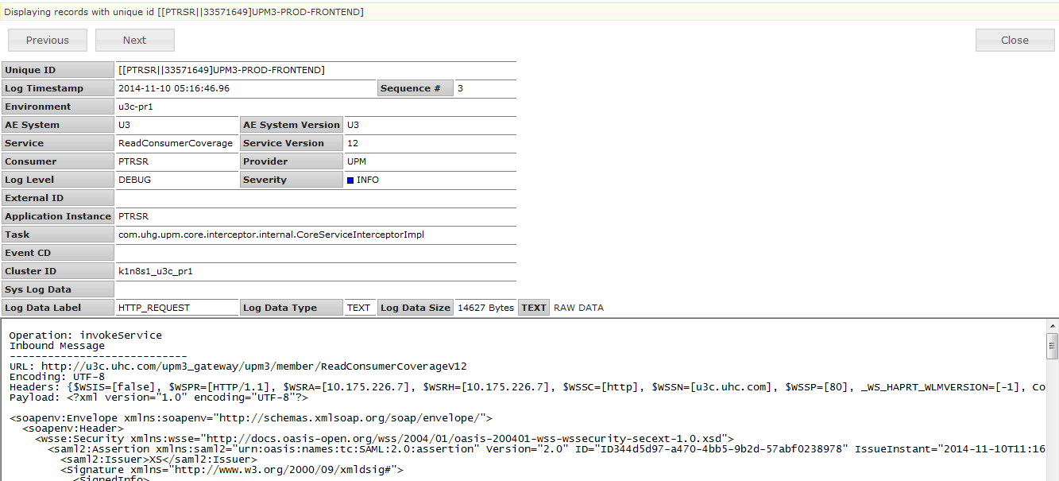
Previous
Next
Message content in XML readable format

Message content in raw format

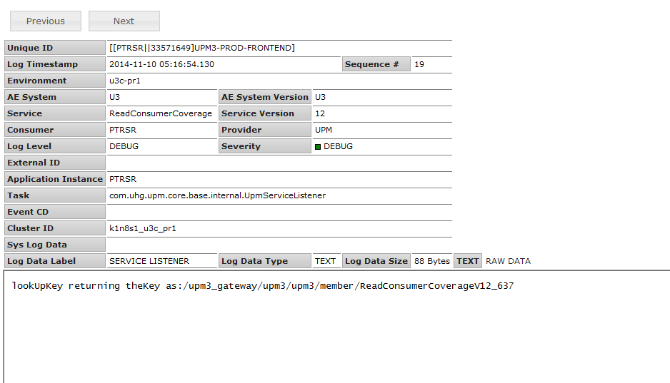
Tabbed view of the message content

Log detail screen for non AE users
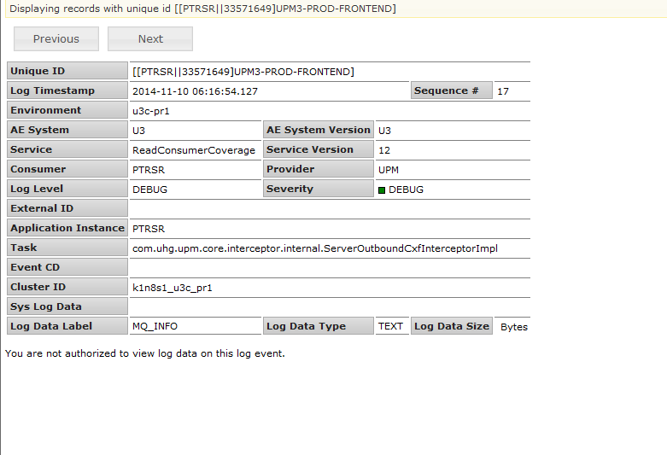

Non AE users cannot view the content of the log message.

Previous / Next buttons
The details of the previous and the next messages can be viewed by clicking the “Previous” and “Next” buttons respectively. The screen is refreshed with the details of the next or previous message. The buttons are grayed out if there are no more messages in the list.

